Slope Stability Analysis by Swedish Slip Circle
Method Using C Programming
Shubhada S. Koranne, Dipak Kumar Mishra and Shweta S. Pande
.
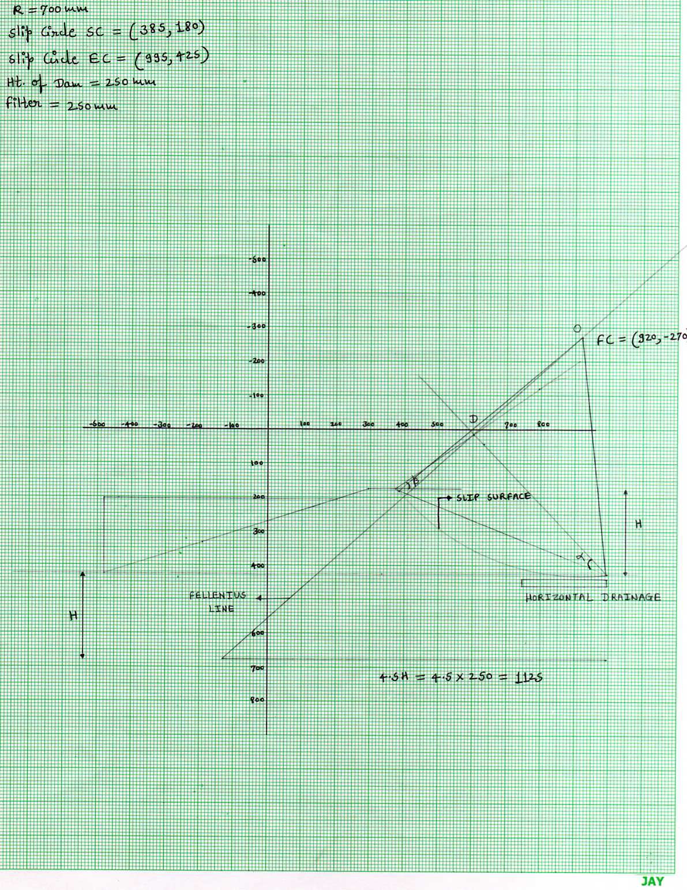
Graph 3.1: Location of centre of slip circle along with Fellenius line
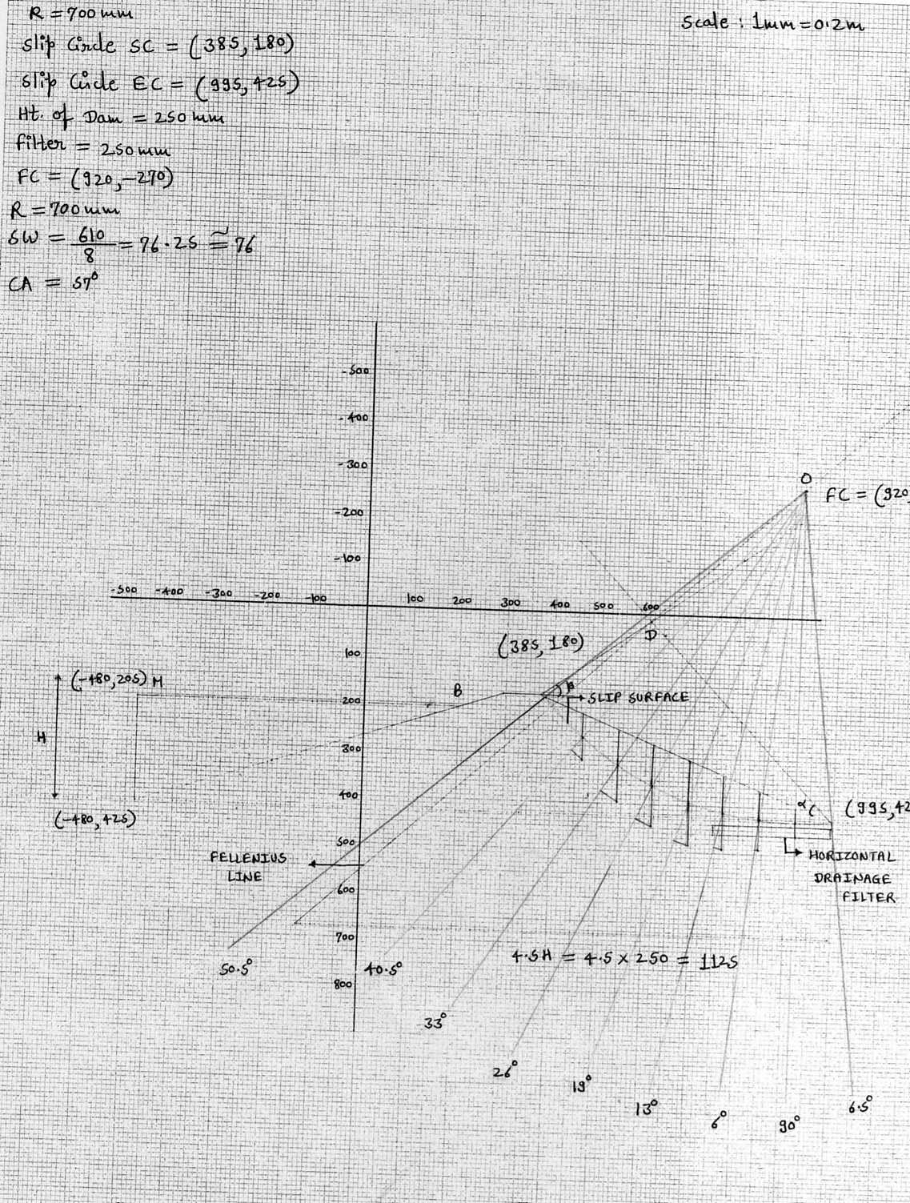
Graph 3.2: Slip circle analysis for D/s slope of the dam
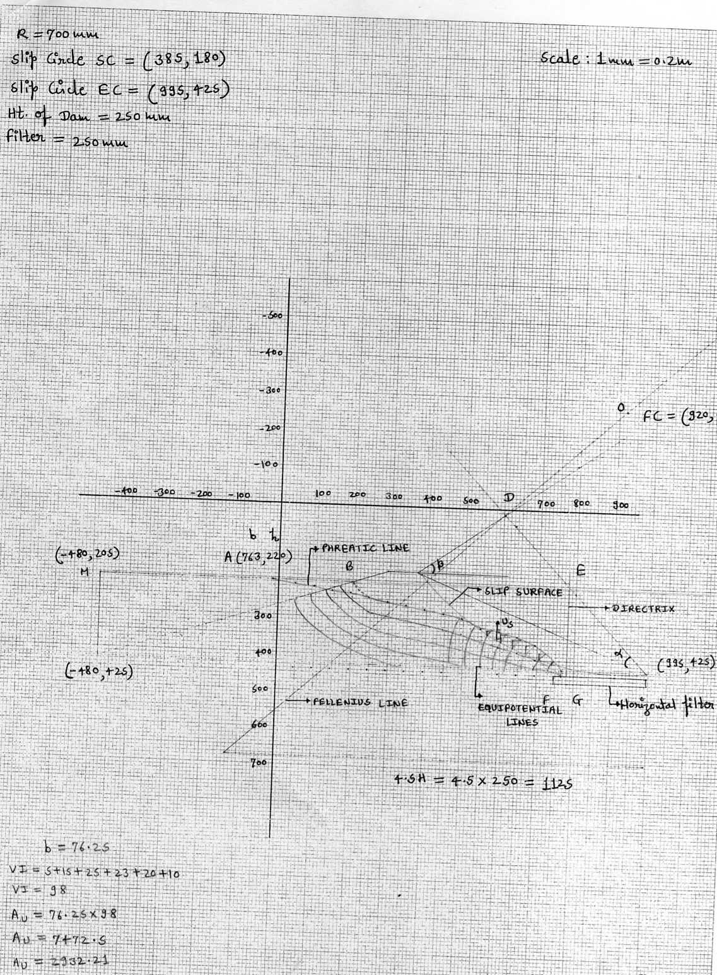
Graph 3.3: Flow net for x=50

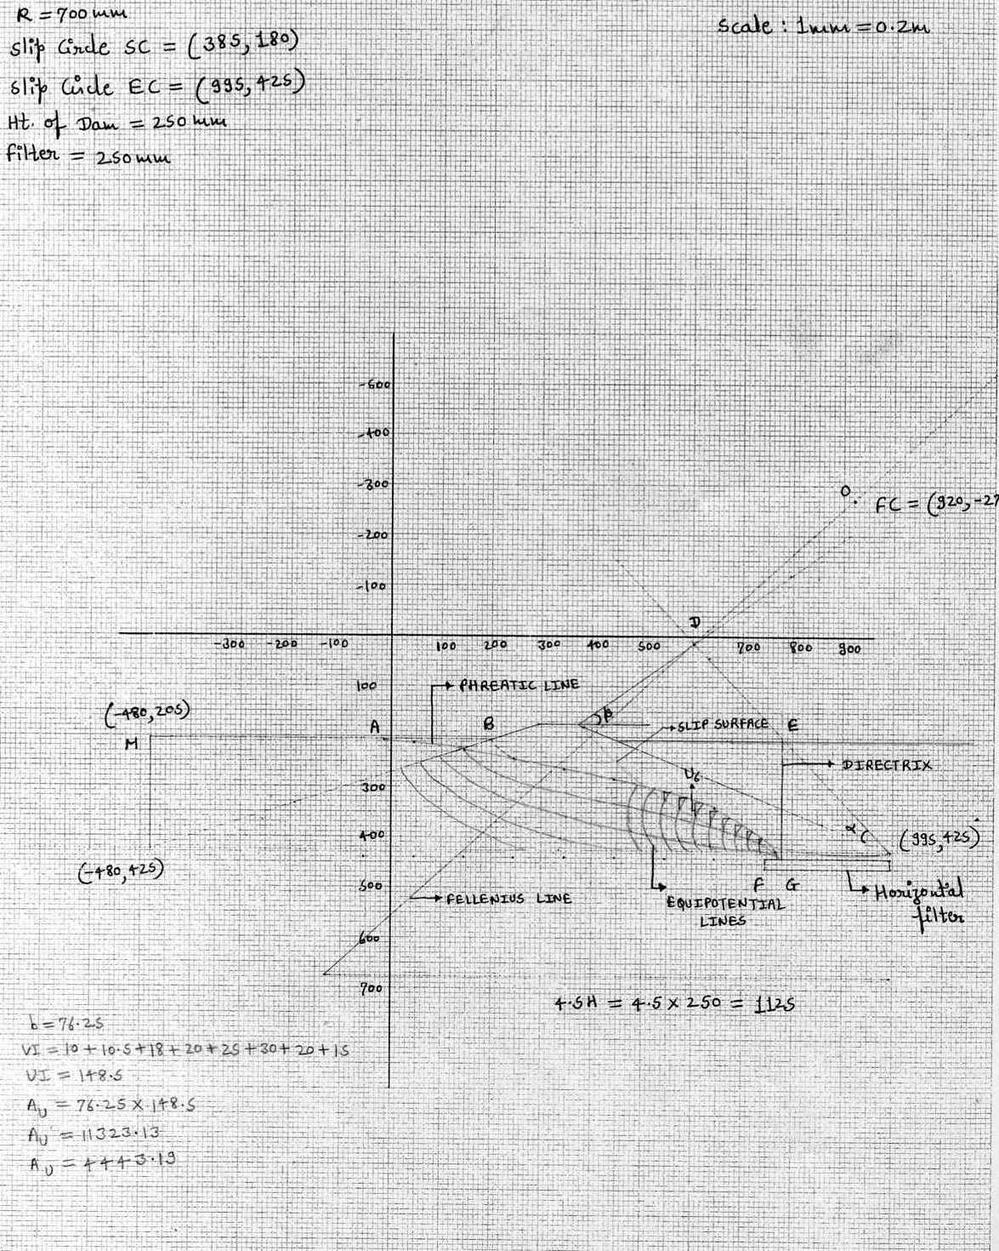
Graph 3.4: Flow net for x=100

