Fuzzy modeling to specify various machining parameters in electrical discharge machining (EDM) of INCONEL625 using copper electrode

P.M.Radia ¹ , M.S.Kagathara ² H.G.Acharya³
1- Assistant Professor, Department of Mechanical Engineering, Atmiya Institute of Technology & Science, Rajkot, India
2- Assistant Professor, Department of Mechanical Engineering, Atmiya Institute of Technology & Science, Rajkot, India
3- Assistant Professor, Department of Mechanical Engineering, Atmiya Institute of Technology & Science, Rajkot, India
Abstract:
Condition monitoring of the machining process is very important in today’s precision manufacturing, especially in the electrical discharge machining (EDM). This paper shows a fuzzy-based algorithm for prediction of material removal rate (MRR) and tool wear ratio (TWR) in the electrical discharge machining (EDM) processes. In this system Peak current(I_{p}), voltage(V) and duty cycle(D) are the input parameters and output parameters are MRR and TWR. The proposed fuzzy model in this study provides a more precise and easy selection of EDM input parameters, respectively for the required MRR and TWR which leads to better machining conditions and decreases the machining costs. The fuzzy modeling of EDM was able to predict the experimental results with accuracies very high.

- Introduction
Electrical discharge machining (EDM) is widely accepted manufacturing process for the machining of materials like super alloys which is not possible to machine by conventional manufacturing processes. INCONEL625 is the hard materials which are widely used in marine, aerospace industry, chemical processing, nuclear reactor, pollution control equipment. To remove the difficulties in machining of INCONEL625, EDM has been the suitable process. Selection of EDM parameters is vague and generally based on heuristics which is difficult to model and is based on the specialty them of person.

2. Fuzzy logic
Fuzzy logic has a history in philosophy and mathematics. Fuzzy logic is a form of mathematical logic in which truth can be assumed between value zero and one. Fuzzy logic designed for situation where information is inexact and traditional on/off are not possible [1]. It divide data into vague categories like hot, medium and cold. Fuzzy logic provide simple way of arrive at definite conclusion based upon the emprise and noise. Fuzzy logic use semantic terms to develop the relationship between input and output variables. Here the fuzzy model has been designed for selecting better EDM parameters. Fuzzification, membership function and defuzzification are main stage for the development of fuzzy model [6].
2.1 Membership function (MF): A membership function is a shape of the profile that shows how point in the input are mapped into membership degree of membership between 0 and 1. There is a number of methods for represent of the membership function that shows fuzziness. Because of the importance of the shape of the membership function; a more attention have been focused on development of the membership functions. There are some types of membership function shapes like triangular, trapezoidal, bell curves and sigmoid.
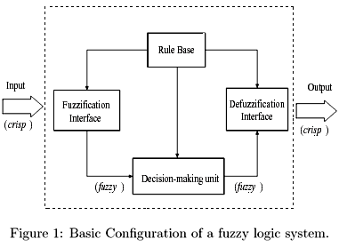
2.2 Fuzzification: Fuzzyfication is the process of transforming crisp input value into linguistic values. There is a various steps of fuzzification. In first step input parameters value is translated into linguistic concept which are related by fuzzy set. In second step membership function are applied to the measurement and degree of membership is determind.
2.3 Defuzzification: Defuzzification is the process of converting fuzzy set value into crisp value. There is a various method of defuzzification are maximum membership method, centroid method and weight average method. Centric of the area is the most widely used defuzzification method which is of the calculation of expected values of probability distributions.
3 Expeiment setup
The experiments was performed to find the effects between input machining parameters (peak current, voltage and duty cycle) on the output machining parameters like material removal rate (MRR) and tool wear ratio (TWR) in electrical discharge machining (EDM) processes. Experiment was carried out on electrical discharge machining Joe mars AZ50. The material used for work piece is INCONEL625 which is nickel chromium super alloy. The electrode material is copper. Peak Current (I_{p}), voltage(V) and duty cycle(D) were selected as a input parameters during machining process. The mass of work piece and electrode before and after measuring with the help of weight measuring instrument with. Material removal rate (MRR) and tool wear rate (TWR) were the output parameters. The schematic diagram of experimental set-up has been shown in figure.

Table 1 Work piece material and properties.
Property | UNIT | VALUE
Density | g/cm3 | 8.44
Melting point range | C | 1290-1350
Ultimate tensile strength | MPa | 827-1103
Hardness | HRC | 175-240
Yield strength | MPa | 414-758
Thermal conductivity | W/m K | 11.4

Table 2 Experimental condition and process variables.
Tool Diameter | 10 mm
Tool Polarity | Positive
Dielectric | Kerosine
Work piece shape | 10*10*5 (mm)
Peak current | 4,13,21 amp
Voltage | 160,180,200 volt
Duty cycle | 0.278,0.477,0.680

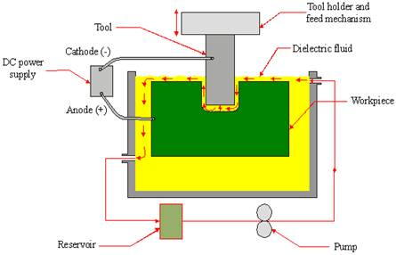

Fig. 2. Schematic diagram of the EDM process.

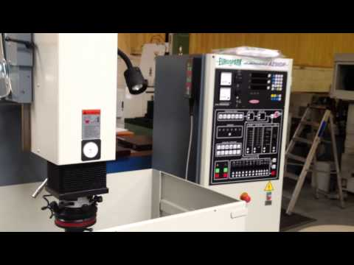
Fig 3 Joemars AZ 50

4 Factorial design and fuzzy expression
Design of experiments (DOE) is a important tool for analysis of affect of input machining parameters on the output machining parameter. The prediction of EDM process, based on the input machining parameter by full-factorial design methods. Full-factorial method was used in the experiment in this paper. The full factorial design was determined on peak current, voltage and duty cycle duration in input machining parameters. Each input machining parameter consists of 3 levels. So there is a three input machining parameters and three levels. So the number of experiment carried out is 3*3*3 = 27. Table 3 gives the result of the experiments. By using of trial and error method, it can be concluded that the triangular membership functions give better results the number of fuzzy sets for Peak current (I_{p}), voltage(V), Duty cycle (D), material removal rate (MRR) and tool wear ratio (TWR) in EDM process. Total number of fuzzy rules used for these experiments are 27.
Table 3 Experimental result of EDM:
Sr no | Peak Current(Ip) amp | Voltage(V) | Duty Cycle | MRR(gm/Min) | TWR(WRR/TWR)
1 | 4 | 160 | 0.278 | 0.007 | 0.029
2 | 4 | 180 | 0.278 | 0.0086 | 0.024
3 | 4 | 200 | 0.278 | 0.0081 | 0.018
4 | 13 | 160 | 0.278 | 0.0134 | 0.011
5 | 13 | 180 | 0.278 | 0.014 | 0.015
6 | 13 | 200 | 0.278 | 0.0143 | 0.015
7 | 21 | 160 | 0.278 | 0.0131 | 0.008
8 | 21 | 180 | 0.278 | 0.0175 | 0.030
9 | 21 | 200 | 0.278 | 0.0142 | 0.008
10 | 4 | 160 | 0.477 | 0.0845 | 0.023
11 | 4 | 180 | 0.477 | 0.1155 | 0.017
12 | 4 | 200 | 0.477 | 0.114 | 0.016
13 | 13 | 160 | 0.477 | 0.12 | 0.019
14 | 13 | 180 | 0.477 | 0.1189 | 0.008
15 | 13 | 200 | 0.477 | 0.1467 | 0.015
16 | 21 | 160 | 0.477 | 0.1163 | 0.021
17 | 21 | 180 | 0.477 | 0.1108 | 0.018
18 | 21 | 200 | 0.477 | 0.263 | 0.010
19 | 4 | 160 | 0.680 | 0.1079 | 0.028
20 | 4 | 180 | 0.680 | 0.2182 | 0.018
21 | 4 | 200 | 0.680 | 0.2696 | 0.011
22 | 13 | 160 | 0.680 | 0.2102 | 0.029
23 | 13 | 180 | 0.680 | 0.2527 | 0.014
24 | 13 | 200 | 0.680 | 0.1822 | 0.013
25 | 21 | 160 | 0.680 | 0.2157 | 0.027
26 | 21 | 180 | 0.680 | 0.28 | 0.007
27 | 21 | 200 | 0.680 | 0.2778 | 0.007

5 Discussion
The result obtained throughout the experimental analysis of material removal rate (MRR) and tool wear ratio (TWR) after period of machining process compare with the result obtained by the fuzzy modeling is discussed.
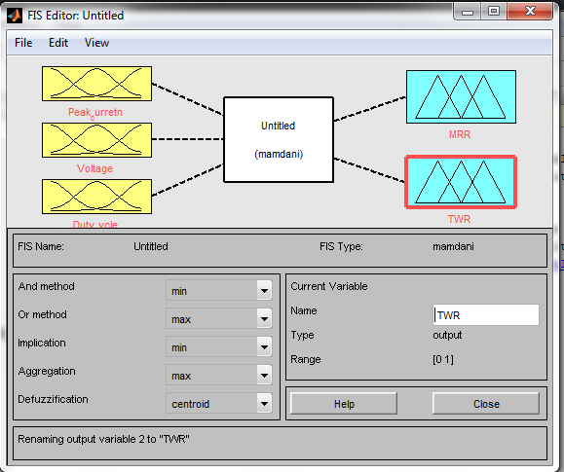
Fig 4 Fuzzy logic parameters
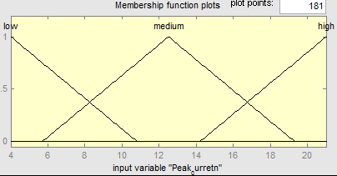
Fig 5 plot degree of membership function for Peak current
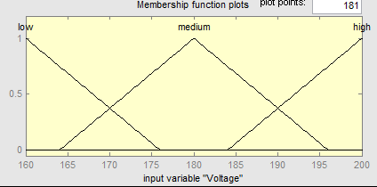
Fig 6 plot degree of membership function for voltage
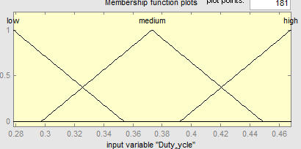
Fig 7 plot degree of membership function for Duty cycle
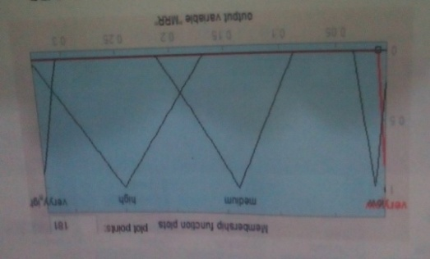
Fig 8 plot degree of membership function for MRR
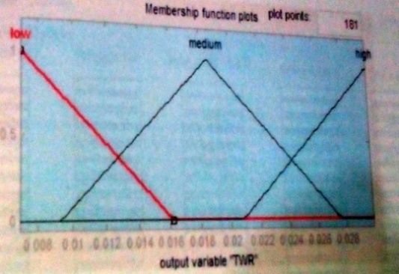
Fig 9 plot degree of membership function for TWR
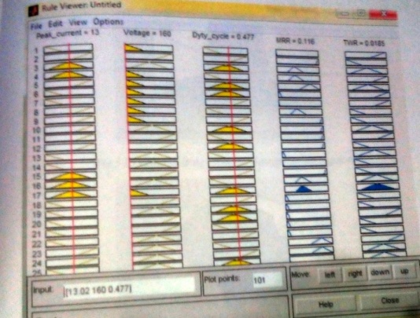
Fig 10 Fuzzy rule viewer
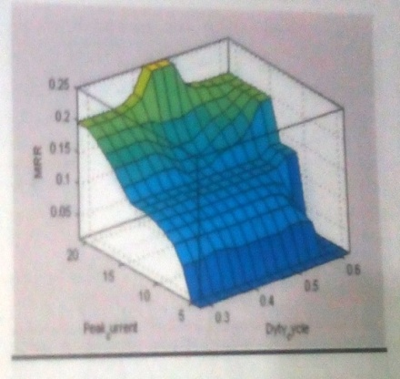
Fig 11 Effect of peak current and duty cycle on MRR
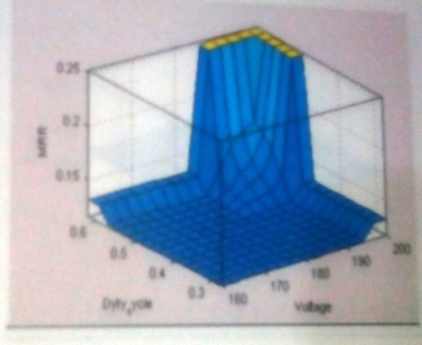
Fig 12 effect of voltage and duty cycle on MRR
Table 4 A part of experimental and fuzzy modeling results for prediction of MRR.
Sr No. | Peak Current | Voltage | Duty Cycle | Experimental  Result of MRR | Modeling Result of MRR
1 | 4 | 160 | 0.278 | 0.007 | 0.00769
2 | 4 | 180 | 0.278 | 0.086 | 0.00769
9 | 21 | 200 | 0.278 | 0.0142 | 0.0151
13 | 13 | 160 | 0.477 | 0.12 | 0.116
19 | 4 | 160 | 0.680 | 0.1079 | 0.11
25 | 21 | 160 | 0.680 | 0.2157 | 0.25

Table 5 A part of experimental and fuzzy modeling results for prediction of TWR
Sr No. | Peak Current | Voltage | Duty Cycle | Experimental  Result of TWR | Modeling Result of TWR
1 | 4 | 160 | 0.278 | 0.029 | 0.027
2 | 4 | 180 | 0.278 | 0.024 | 0.0269
9 | 21 | 200 | 0.278 | 0.008 | 0.0099
13 | 13 | 160 | 0.477 | 0.016 | 0.0185
19 | 4 | 160 | 0.680 | 0.028 | 0.0099
25 | 21 | 160 | 0.680 | 0.027 | 0.0099

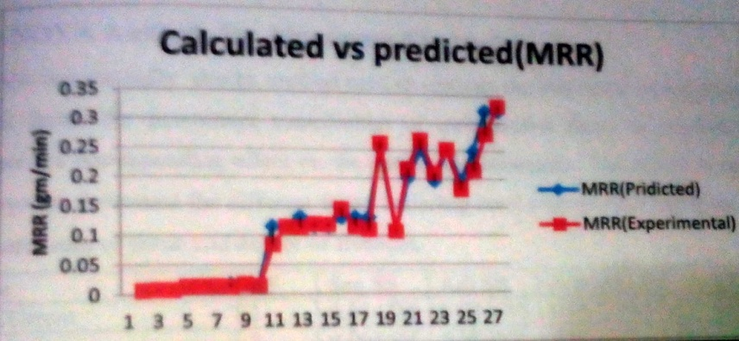
Fig 13 Calculated Vs predicted graph for MRR
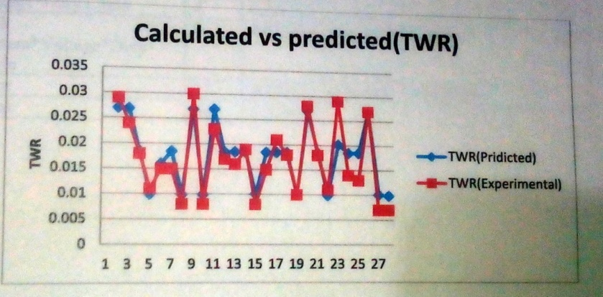
Fig 14 Calculated Vs predicted graph for TWR
6 Conclusions
Observation indicates that fuzzy modeling result of EDM were in good agreement with experimental finding demonstrating approximately 90% prediction rate achieved. Experimental result indicate in machining of INCONEL625, the MRR increased with the increased in peak current and duty cycle, voltage is comparatively less influential parameter. In additional TWR decreased with increased in duty cycle.

Rererence:
[1] M.R. Shabgarda,∗, M.A. Badamchizadehb, G. Ranjbarya, K. Aminic “Fuzzy approach to select machining parameters in electrical discharge machining (EDM) and ultrasonic-assisted EDM processes” Journal of Manufacturing Systems 32 (2013) 32– 39

[2] Tzeng YF, Chen FC. Multi-objective optimisation of high-speed electrical discharge machining process using a Taguchi fuzzy-based approach. Journal of Materials Processing Technology 2007;28:1159–68.
[3] Lin CT, Chung IF, Huang SY. Improvement of machining accuracy by fuzzy logic at corner parts for wire-EDM. Fuzzy Sets and Systems 2001;122: 499–511.

[4] 1Anoop Kumar Singh, 2Sanjeev Kumar, 3V.P. Singh “Electrical Discharge Machining of Superalloys: A Review” IJRMET Vol. 3, Issue 2, May – Oct

[5] Rajyalakshmi. 1, Venkata Ramaiah. P 2 “Optimization of Process Parameters of Wire Electrical Discharge Machining Using Fuzzy logic Integrated with Taguchi Method” International Journal of Scientific Engineering and Technology (ISSN : 2277-1581)
Volume No.2, Issue No.6, pp : 600-606

